Setting up the Activity Fund Expense and Revenue Purchase Orders

Fiduciary funds include assets the district holds in trust for others that cannot be used to support district programs, such as scholarship funds (Fund 810), Campus Activity (fund 461) and Student Activity funds (Fund 865). GASB 84 changed the accounting procedures for fiduciary funds so Student Activity funds will now require revenue and expenditure codes, not just the cash and liability codes most of us have been using. We are attaching additional information on GASB 84 and from TASB regarding fiduciary funds. To establish the proper accounting, complete the following checklist. As always, feel free to contact the TxEIS Business team with questions.

- Remove the Student Activity Fund > Fund / Fiscal Year, if showing in
Finance > Tables > District Finance Options > Finance Options

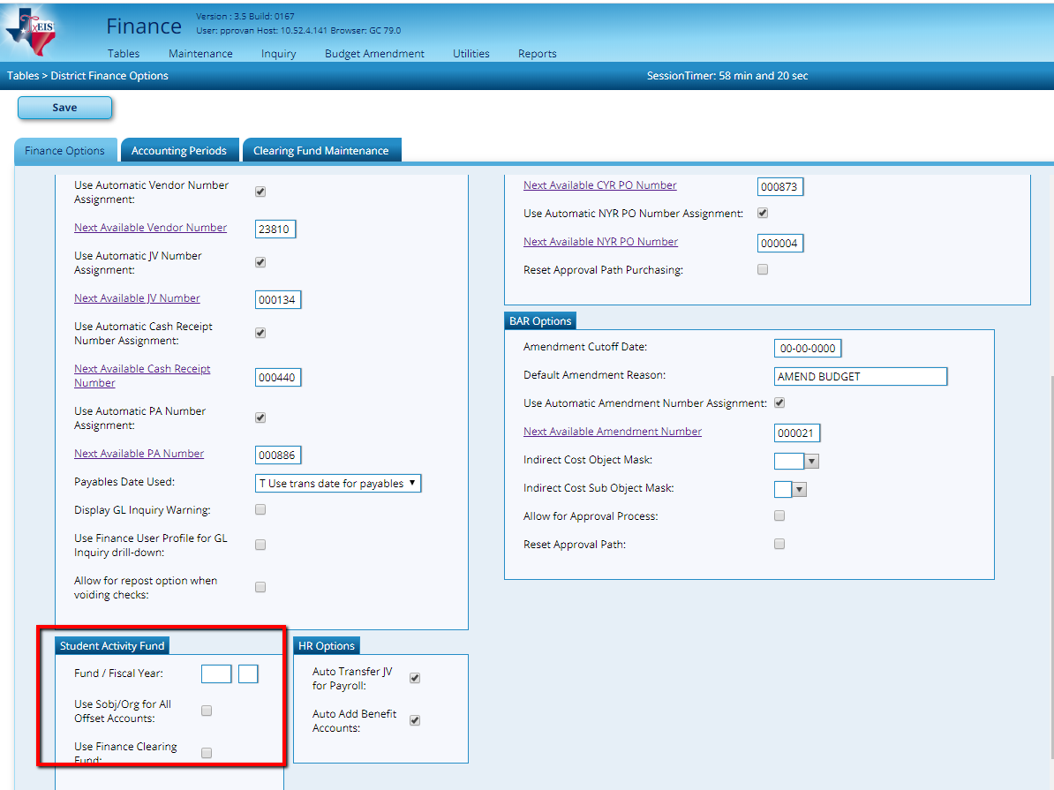

- Add Fund 865 to
Finance > Tables > Account Codes > Fund tab if needed.
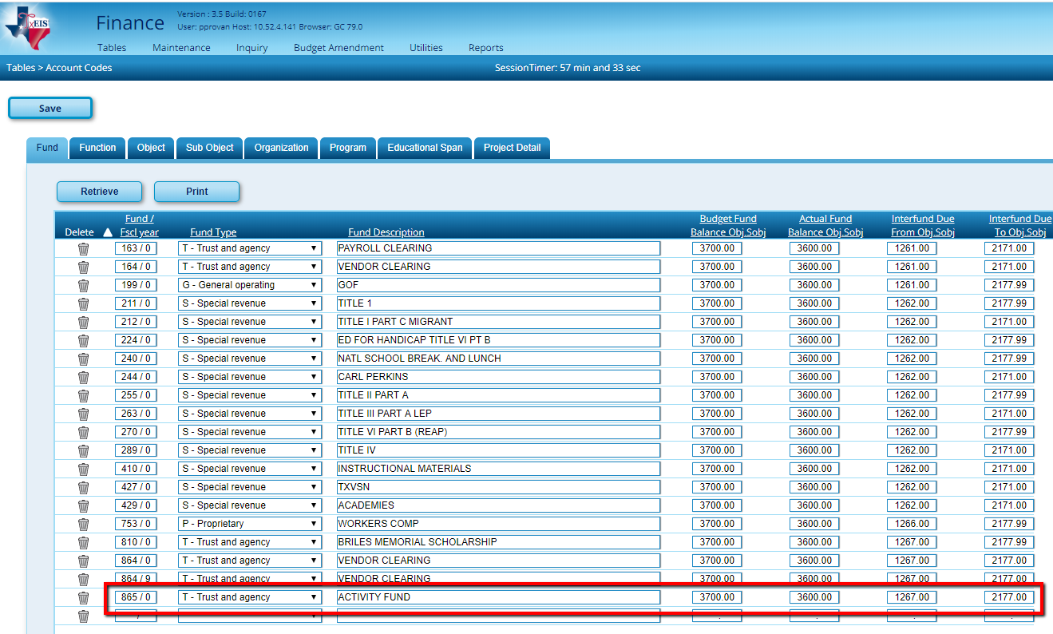

- Enter the Revenue, Expenditure and Fund Balances Account Codes in
Finance > Maintenance > Create Chart of Accounts
Use Sub-Object, Educational Span or Projected Detail fields to account for each organization separately.
Examples:
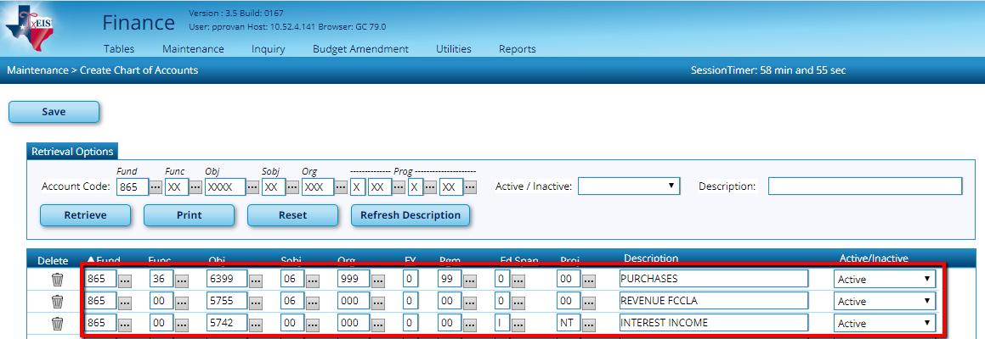
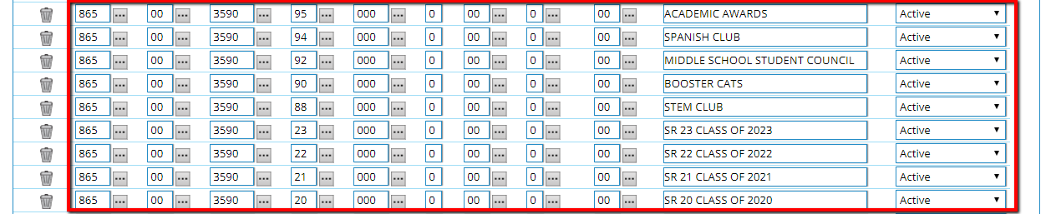

If you use the Purchasing Application and print PO’s for
Student Activity purchases, complete steps 4-5.

Or

If you document purchases in Student Activity funds on a paper PO and then enter a PA in Finance, skip to step 6.

- Districts using Purchasing must enter a Budget Amendment to establish budget amounts in Revenue and Expenditure accounts.
Finance > Maintenance > Postings > Journal Budget

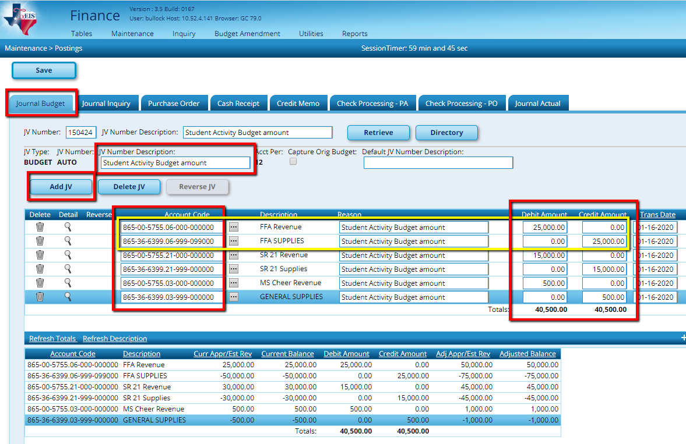

- Set up users to Purchase in

District Administration > Maintenance > User Profiles > Accounts

- Add desired accounts in Fund 865 for each user. Select PUR

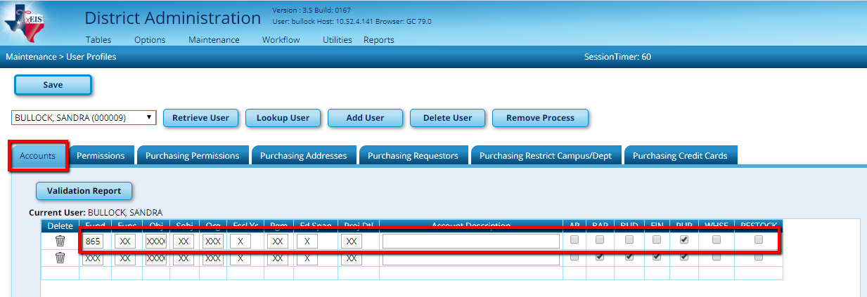

- Enter JV to reclassify existing activity into Revenue and Expense accounts from 219X in
Finance > Maintenance > Postings > Journal Actual

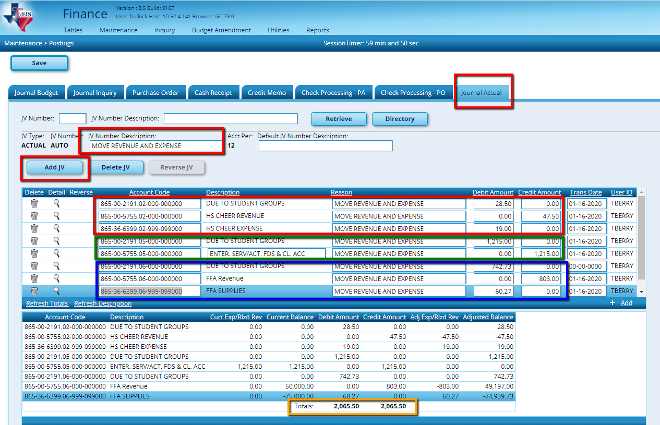
Opening balances should be entered in 3590 fund balance.

- If your district will use purchasing, ensure appropriate staff know to use 865-XX-6XXX rather than 865-00-219X
Purchasing > Maintenance > Create / Modify Requisition
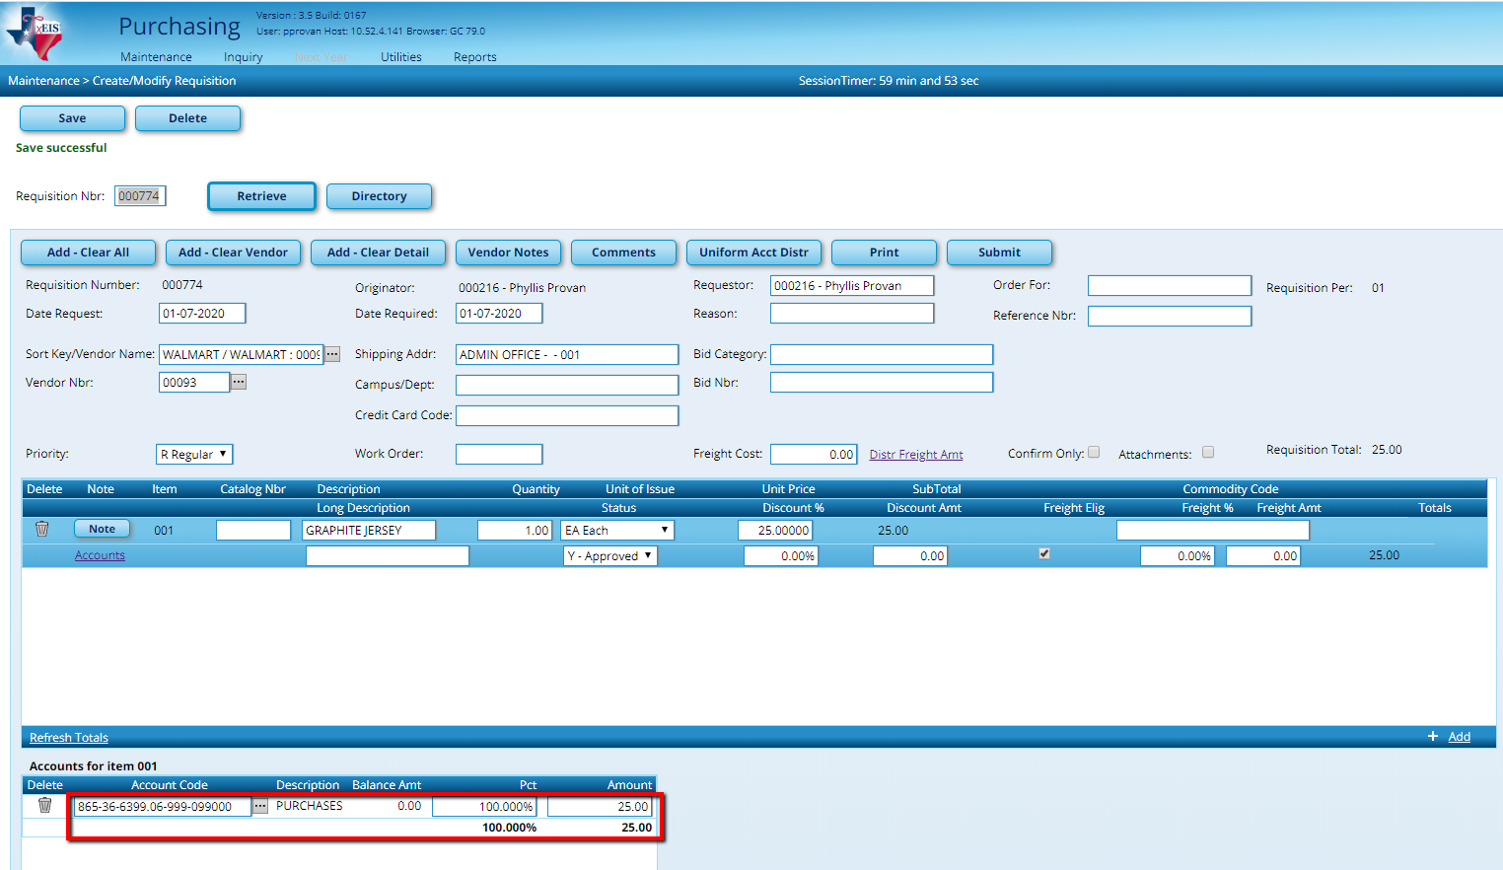

Notes 1: FIN1850 - Student Activity Report will no longer work for Student Activity.
Notes 2: You may need to reverse or pay any pending PO's with 865-00-219X.

